
Quick Guide

Enroll in Benefits – New Hires
///////////////////////////////////////////////////////////////////////////////////////////////////////////////////////////////////////////////////////////////

Introduction
In this quick guide you’ll learn how to enroll in benefit plans in Oracle Cloud, including: adding dependents and beneficiaries, selecting coverage options, and submitting required documentation to ensure proper coverage assignment and approval.
Quick StepS
Get Started
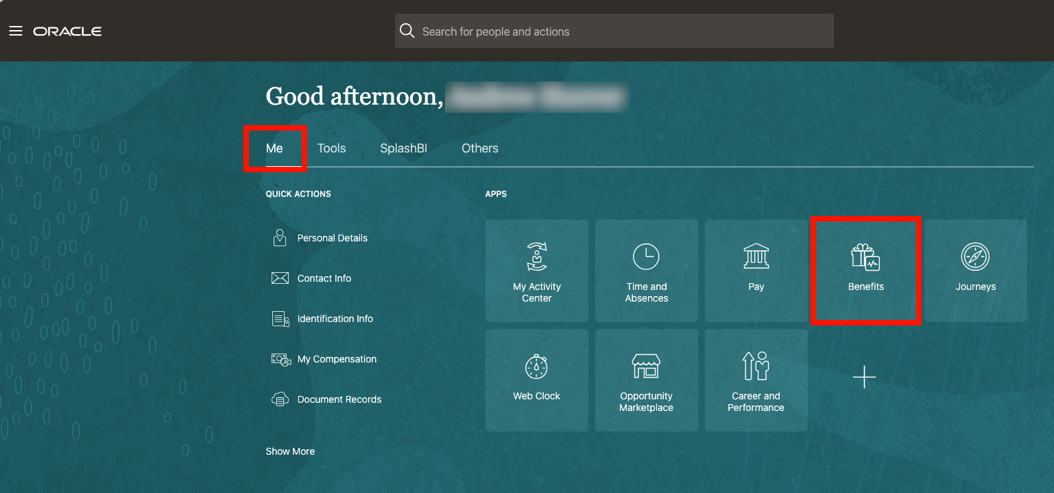
Step #1: From the Me tab, select Benefits.
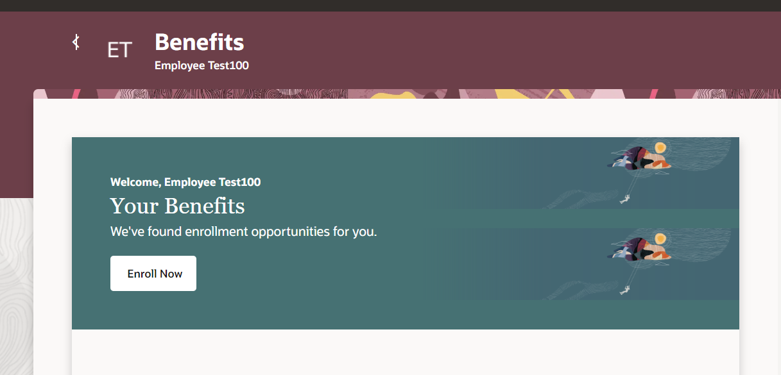
Step #2: Select Enroll Now.
Step #3: Select Choose how you want to enroll, then select Discovery.
Step #4: Select Continue.
Add dependents & beneficiaries
Dependents and beneficiaries must be added first, before you enroll in benefits.
Step #1: Select Verify people you’d like to cover.
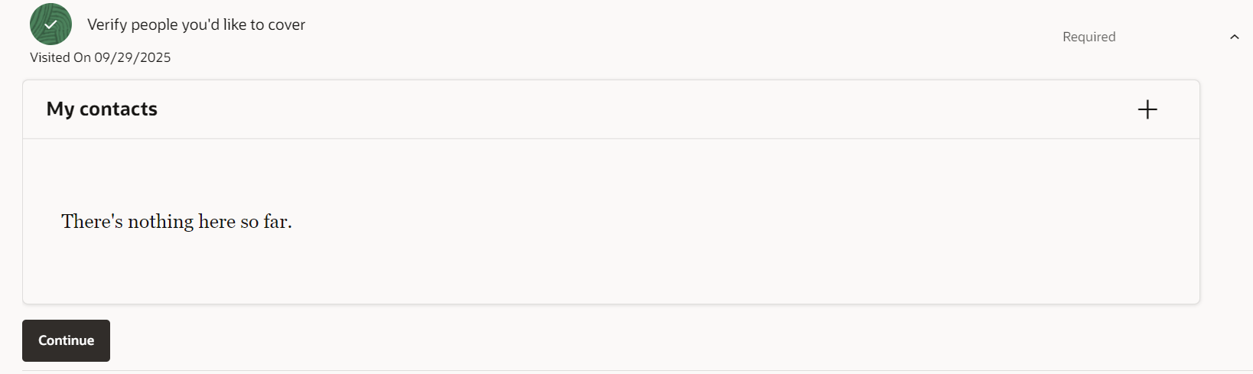
Step #2: Select the plus sign (+) next to My contacts.
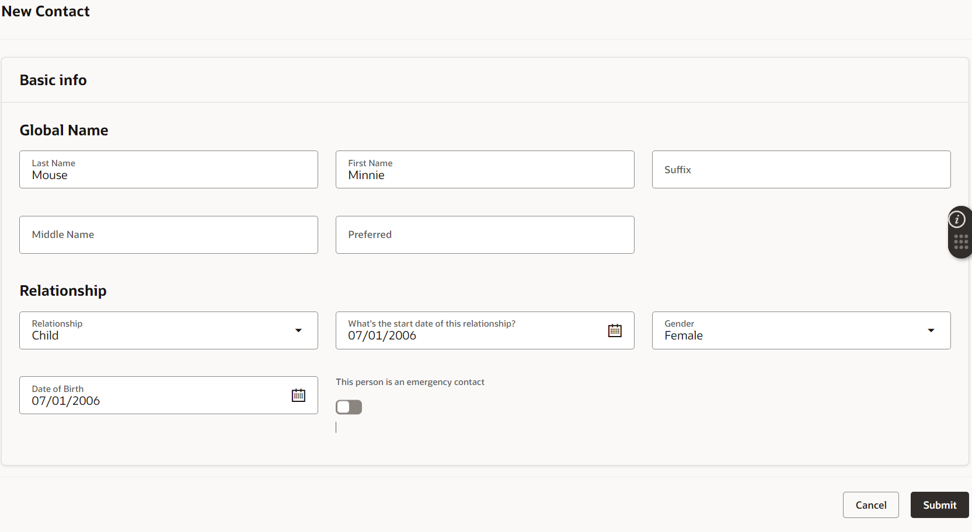
Step #3: Complete the required information.
Step #4: Select Submit.
Step #5: Repeat Steps 2–4 for each dependent you want to cover and each beneficiary you want to designate.
Step #6: After you’ve entered all dependents and beneficiaries, select Continue.
Choose benefits & select dependents to cover
Step #1: Select Enroll in benefits that matter to you.
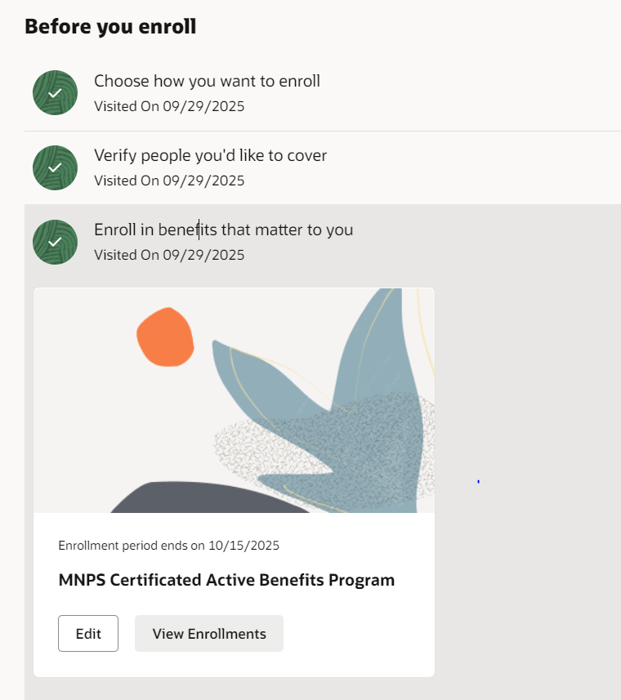
Step #2: Select Edit.
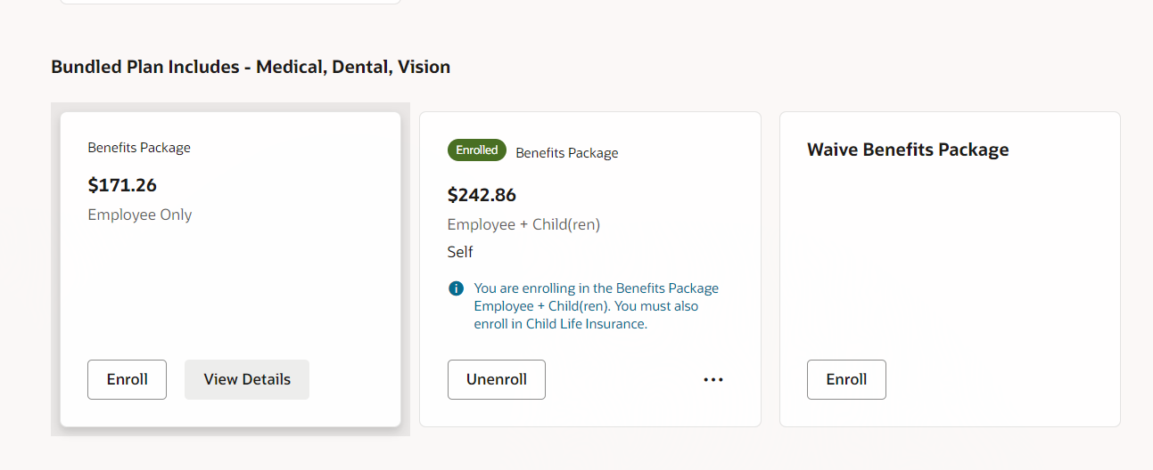
Step #3: The benefit options available to you will appear on the screen. For each one that you would like to enroll in, select Enroll.
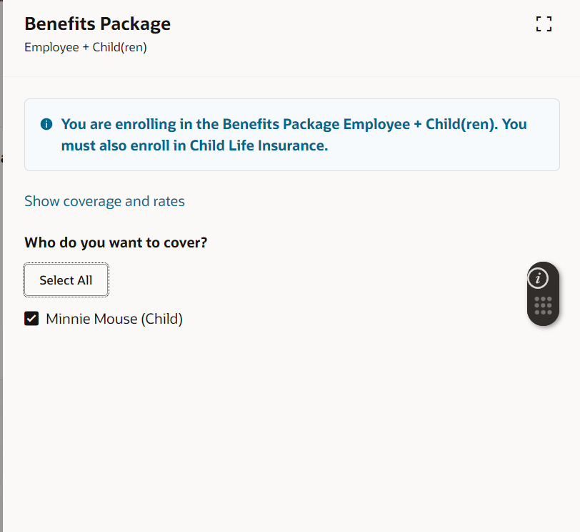
Step #4: Select the dependents you entered earlier that you would like to cover under each plan.
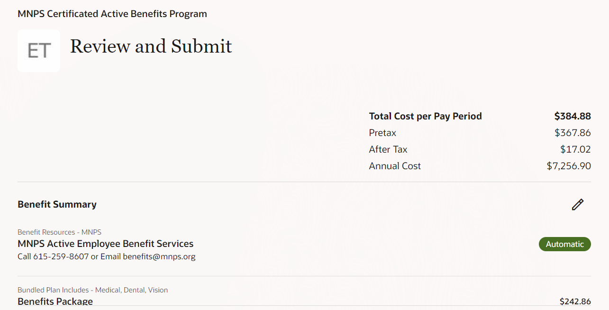
Step #5: When you’re finished, review your selections. To make changes, select the pencil icon. When everything is correct, select Submit.
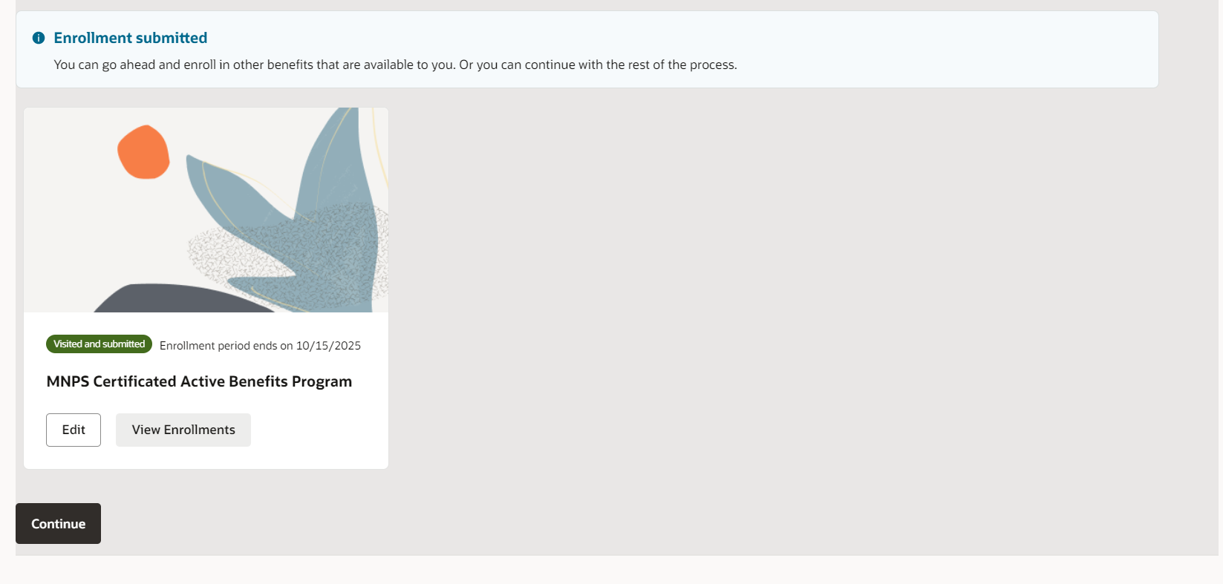
Step #6: Select Continue.
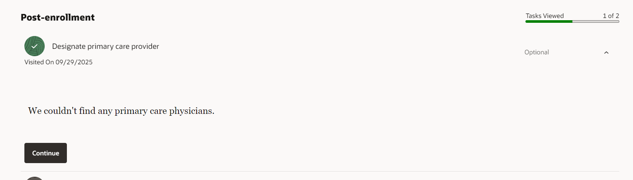
Step #7: The next section will ask if you would like to add your Primary Care Physician. This is optional. Select Continue to proceed.
Add required dependent documentation & designate beneficiaries
All items shown under Complete Pending Actions must be completed for your coverage to be assigned appropriately. This includes adding documentation for dependents (like a birth certificate, marriage certificate, etc.) and designating beneficiaries for life insurance plans.
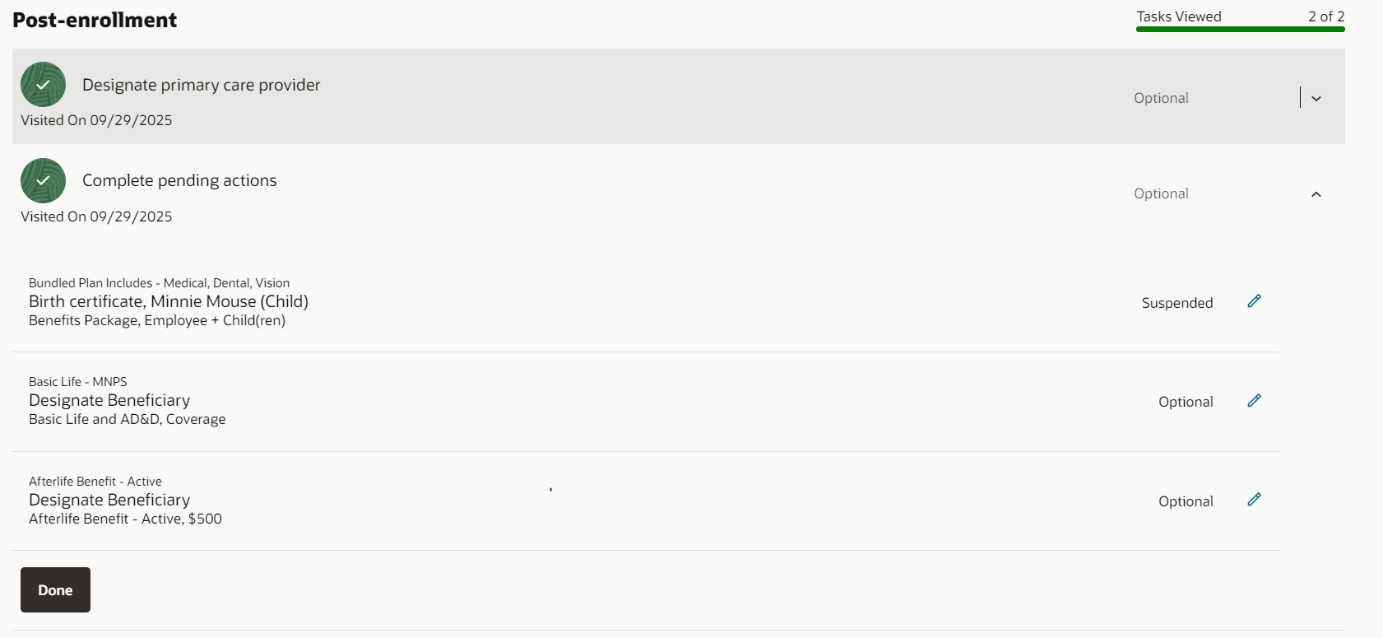
Step #1: Next to a pending action, select the pencil icon.
Step #2: Make the required edits:
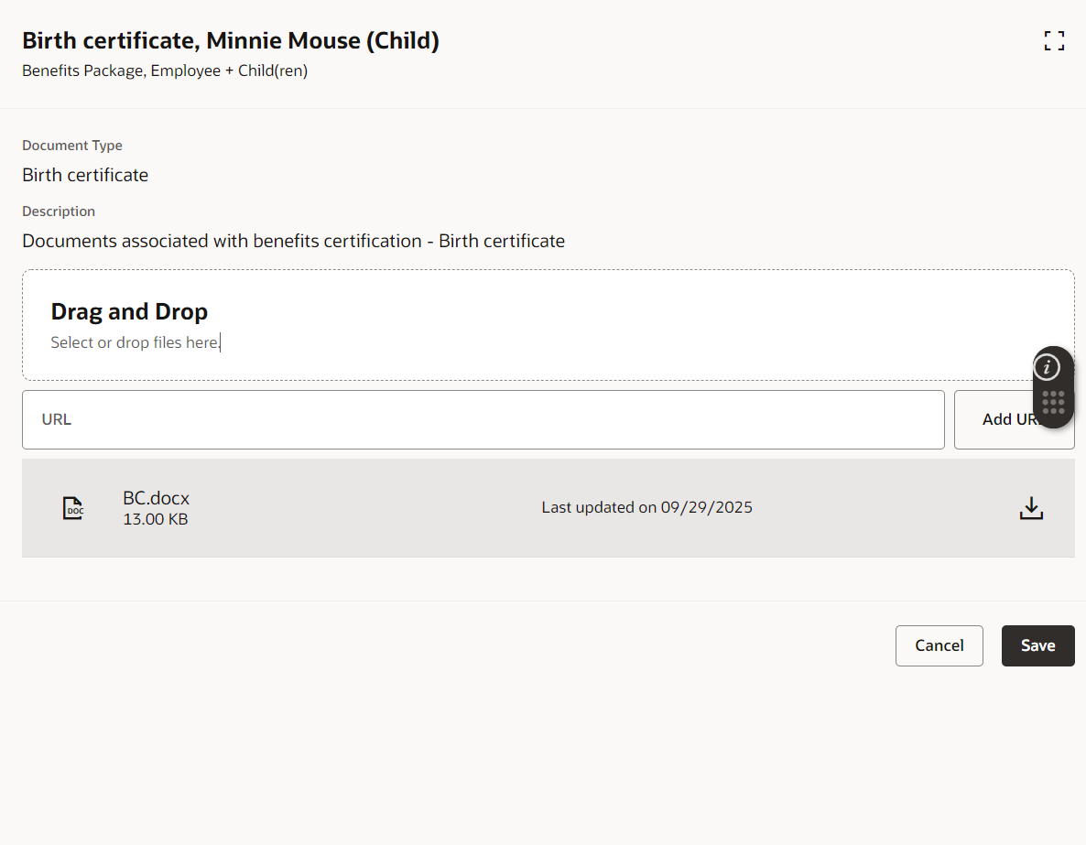
- For dependents to be covered: drag and drop the required file onto the field to upload, then select Save. The item will now show as Pending approval by HR.
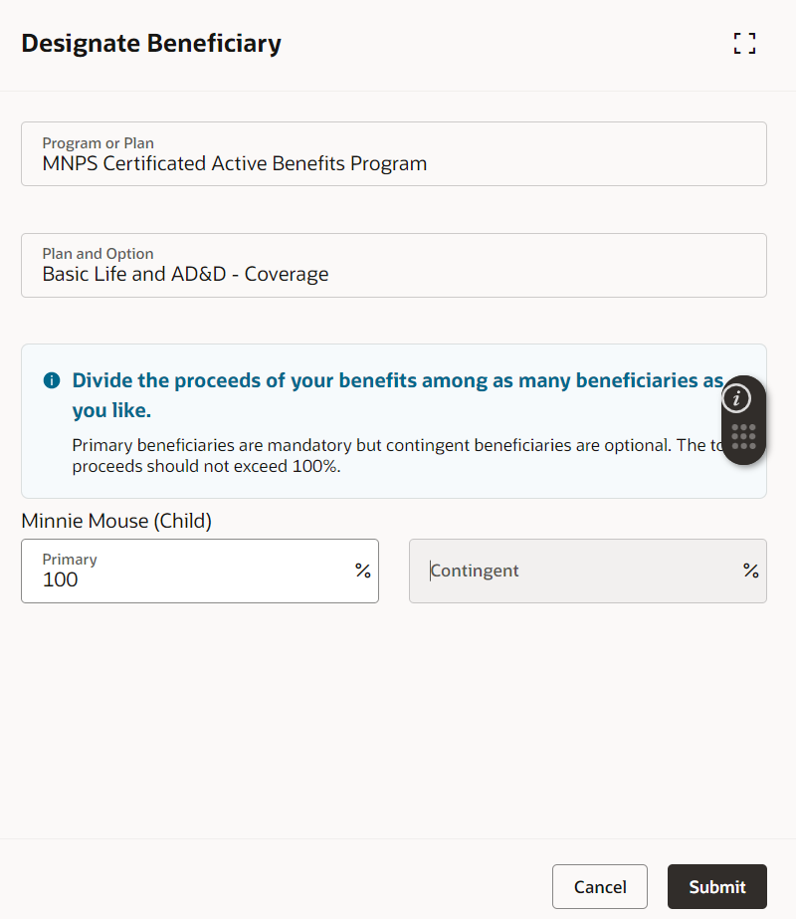
- For life insurance beneficiaries: select the person(s) and the percentages for each person, then select Submit.
Step #3: Repeat steps 1 and 2 for each pending item.
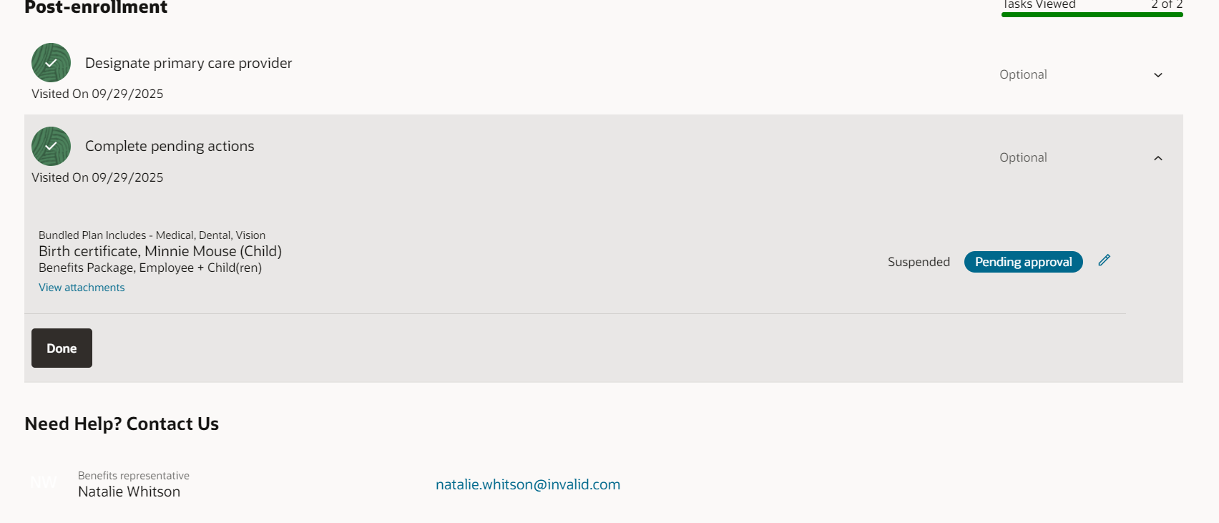
Step #4: When the only item(s) listed show as Pending approval, select Done.
Finish
This will take you back to the enrollment screen. You’ll see the items pending approval and the last date you can make changes to your enrollments.
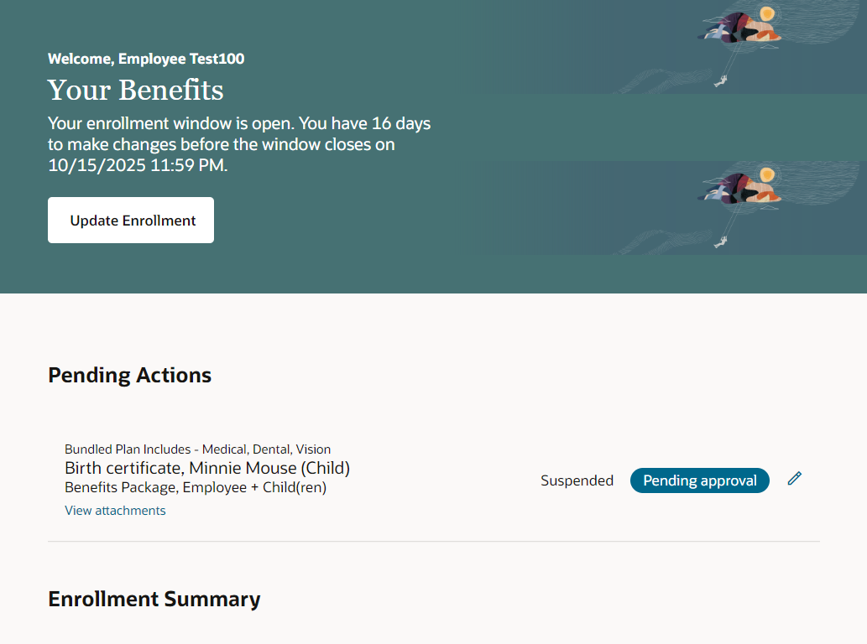
You have successfully made your enrollment selections.
About Oracle Cloud
Oracle Cloud is the system Metro Nashville Public Schools uses to support every stage of your employee journey — from hiring to retiring. It’s a secure, online platform that brings all your HR needs together in one place. From pay and benefits to leave and timekeeping, Oracle Cloud makes it simple to find the information you need, whenever you need it. Click. Cloud. Done.

